A Reminder for “MEMORIZED” Expressions in IYS Essays:

Although IYS essays require students to follow certain formats of essays and essay conventions, here at YTU School of Foreign Languages, we equally value our students’ genuine attempt to express their own ideas in a well-developed essay.

Some students find it easy to memorize various formulaic expressions in their essays. They combine these memorized generic phrases with the words/phrases taken from the essay question in the introduction, body or conclusion paragraphs. Essays which contain this type of formulaic language have several problems. In these essays,

- there are overgeneralized introduction and conclusion paragraphs with no relevance to the topic.
- there are made-up statistics or expert ideas with no real reference.
- some grammatical errors arise as the student tries to fill in the blanks in the formulaic expressions with his/her own words or the given prompts.
- these generic phrases take up so much space in the essay that the essay looks quite smart and shiny. Yet, there are so few original sentences that belong to the writer.
- some sentences do not even make sense although they look grammatically perfect.

Therefore,
- Do not fill up your essay with memorized phrases or generic writing expressions! They will make your essays incoherent and void of originality. They will add NO value to the content of your composition.
- Focus on the quality, not the quantity, of your sentences and paragraphs.
- Think before you write! Find relevant ideas, examples, facts, explanations to support your opinion before starting to write your sentences.
- Practice makes perfect. Write as many essays as possible using your own words and sentences. If you continue to use these memorized phrases, you will soon lose your own voice and won’t be able to create an original piece of writing any more.
These generic expressions and memorized sentences automatically lower your score for the content of your essay.

Here is a student essay* which is mostly full of memorized sentences and formulaic expressions. This is not an effective way to answer essay questions in IYS exam.
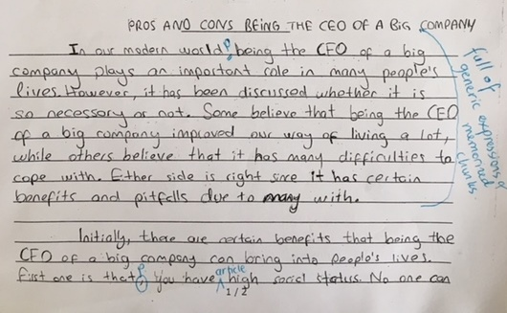
Memorized expressions in the Introduction paragraph

- However, it has been discussed whether it is so necessary or not.

- Some believe that being the CEO of a big company improved our way of living a lot, while others believe that it has many difficulties to cope with.

These sentences display examples of generic expressions which are memorized and adjusted to the given topic. Yet, they are too general and not natural.

- Either side is right since it has certain benefits and pitfalls due to many with.
ungrammatical phrase

This sentence shows that some grammatical mistakes may arise while trying to complete a memorized sentence with a topic-related word.

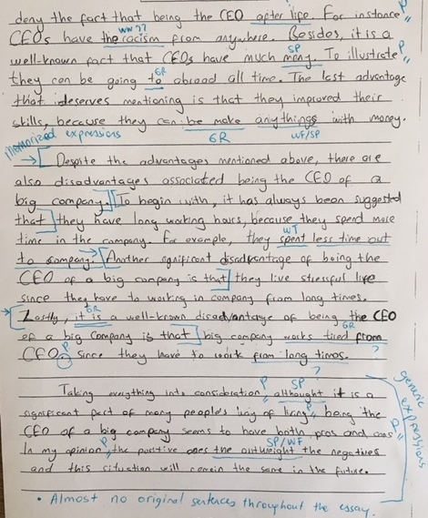
Some phrases in the 2nd body paragraph
- There are certain benefits that being the CEO of a big company can bring into people’s lives.
- No one can deny the fact that……………
- It’s a well-known fact that …………………
- The last advantage that deserves mentioning is that……………………..
Using these expressions is not wrong. Yet, if you do not explain your ideas with appropriate justifications, these ‘smart’ phrases do not add meaning to the content of your paragraph. They just give the wrong impression that there are a lot of ideas in one paragraph.
2nd body paragraph
There are certain benefits that being the CEO of a big company can bring into people’s lives. First one is that you have high social status. No one can deny the fact that being the CEO after life. For instance, CEOs have the racism from anywhere. Besides, it’s a well-known fact that CEOs have much money. To illustrate, they can be going to abroad all time. The last advantage that deserves mentioning is that they improved their skills because they can be make anythings with money.
Student’s original sentences (in bold and underlined) contain some vocabulary and grammar mistakes. They are too short and not developed at all.
Throughout this essay, these ready-made expressions take up so much space that the essay looks quite smart and shiny. Yet, there are so few original sentences that belong to the writer.
Conclusion paragraph
This paragraph is also full of generic sentences.
- Although it is a significant part of many people’s way of living, being the CEO of a big company seems to have both pros and cons.

- In my opinion, the positive ones the outweight the negatives and this situation will remain the same in the future.

Being a CEO is NOT a significant part of MANY people’s way of living. This sentence is not meaningful in real life. Last sentence (“…and this situation will remain the same in the future.”) is quite vague as well. It is apparent that this sentence is meant to be written for another debatable topic in another essay.

*This essay received a score between 6-8 points out of 25 in IYS due to the problems mentioned above.

